- Switching Basics Theory

Q1. Open Cisco Packet Tracer or any network simulator, create a simple network with one switch and two PCs, and use the 'show mac address-table' command to observe how the MAC address table is initially empty?

Answer
- I created a simple network in Cisco Packet Tracer using one 2960 switch and two PCs.
- I connected both PCs to the switch and used the show mac address-table command to check the initial MAC address table.
- I observed one dynamic MAC address entry on port Fa0/2 before sending any manual ping.
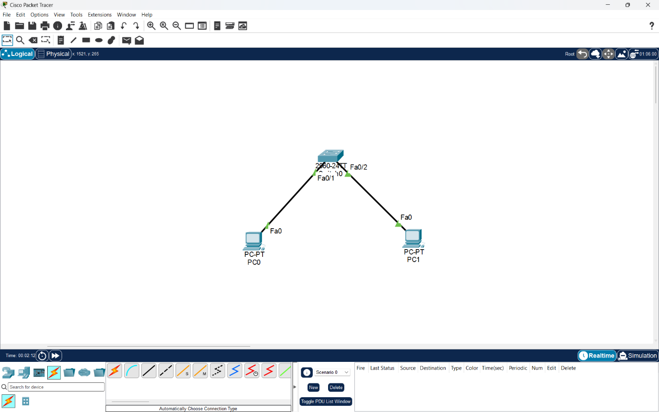
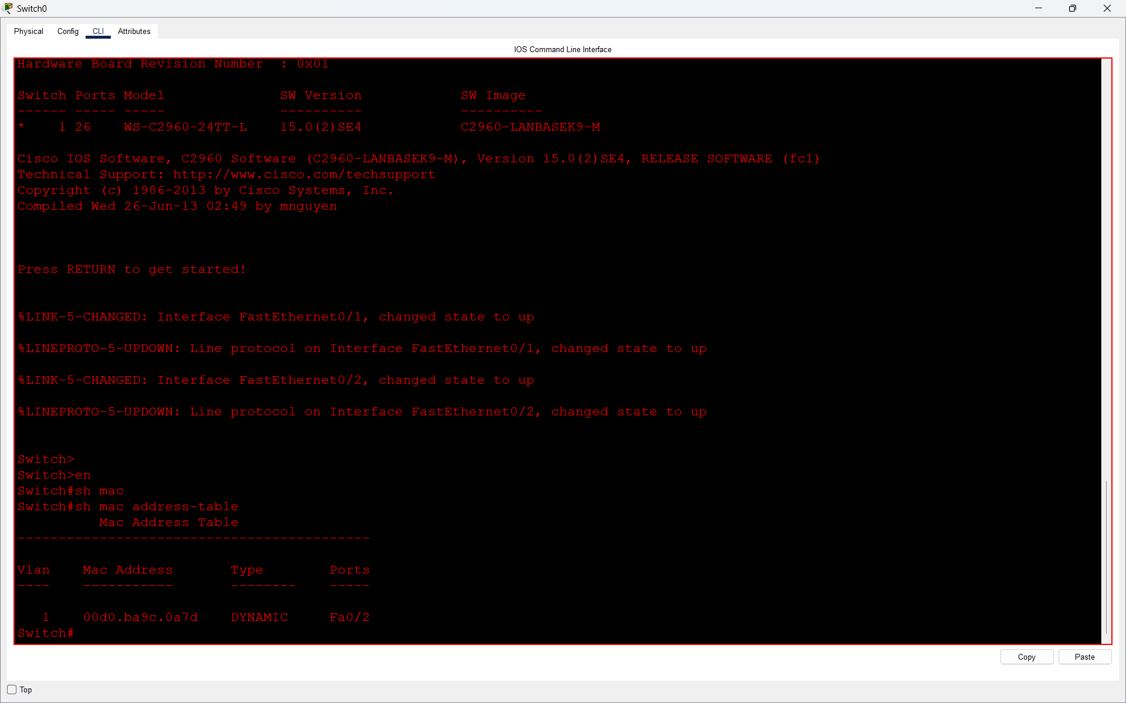

Q2. Send a ping from PC1 to PC2 in your simulated network, then immediately run 'show mac address-table' on the switch and note how the MAC addresses of both PCs appear in the table.<br><br><em><strong>Hint:</strong> Try pinging in both directions to see how the table updates.</em>?

Answer
- I sent a ping from PC0 to PC1 using the ping 199.168.1.2 command.
- The ping was successful with 0% packet loss.
- After communication, I checked the switch's MAC address table using the show mac address-table command to observe the learned MAC addresses.
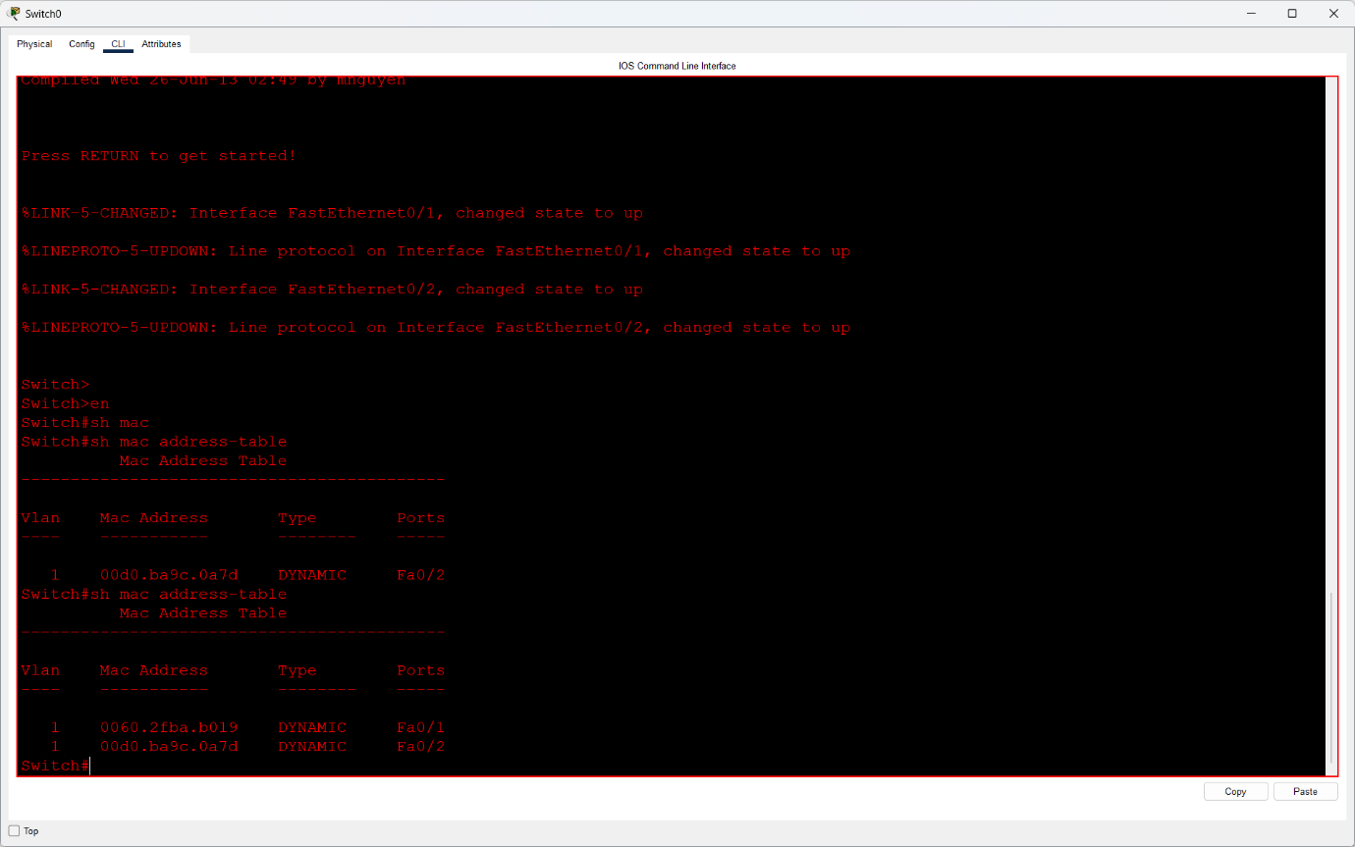
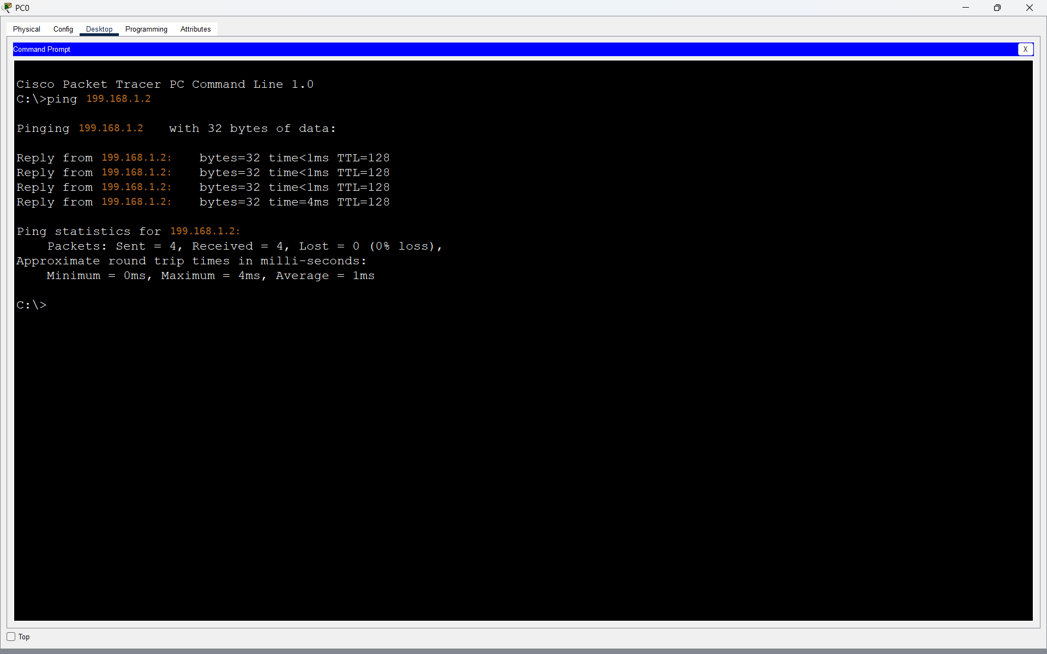

Q3. Add a third PC to your network, connect it to the switch, and ping from PC3 to PC1. Observe and record how the MAC address table changes after this communication?

Answer
- I added a third PC (PC2) to the existing network and connected it to Switch0 using port Fa0/3.
- I assigned IP address 199.168.1.3 to PC2 and pinged PC0 at 199.168.1.1.
- After the successful ping, I checked the switch MAC address table using show mac address-table.
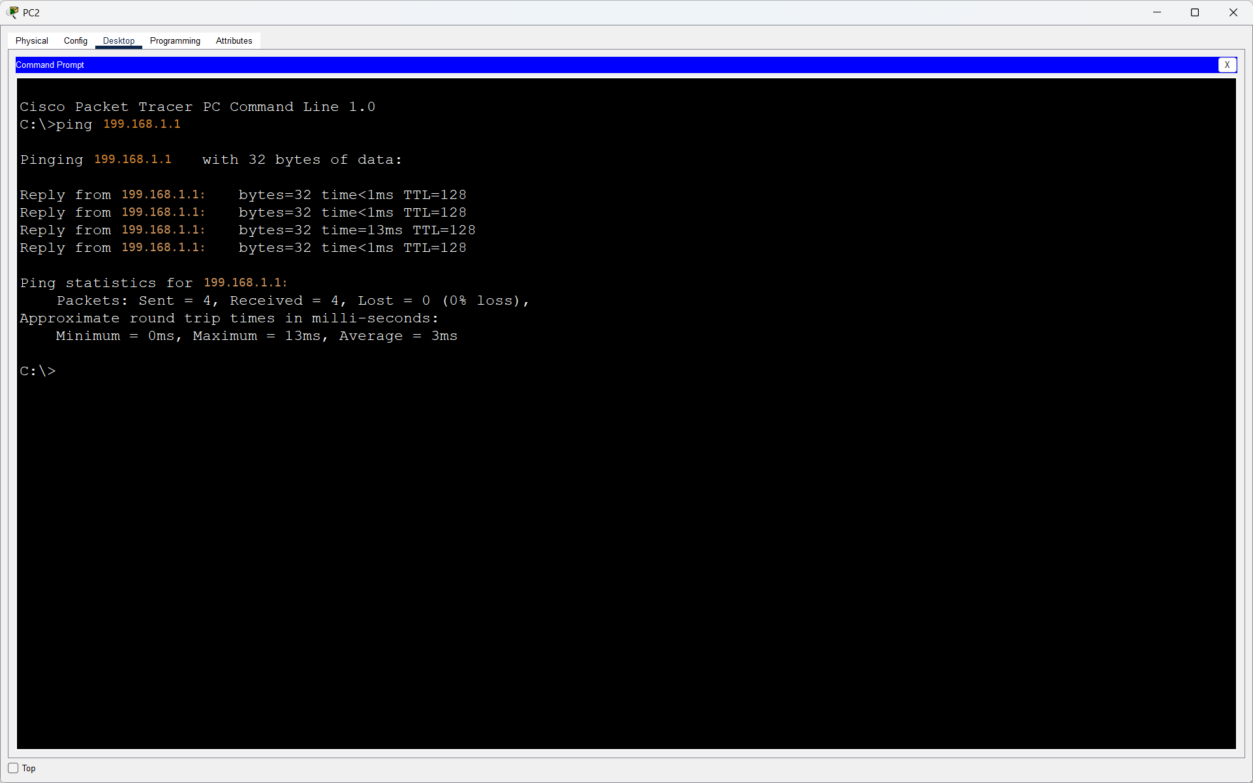
- I observed that a new MAC address, 00e0.a351.1eeb, was learned dynamically on port Fa0/3.

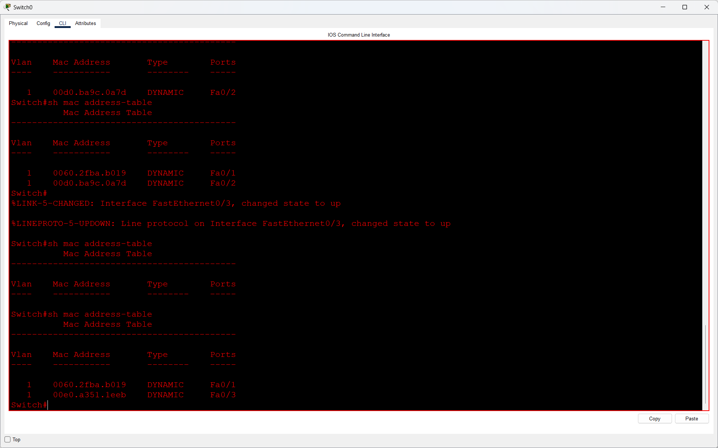

Q4. Suppose you see the following MAC address table on a switch: Port 1 - 00:11:22:33:44:55, Port 2 - 66:77:88:99:AA:BB. If a frame arrives at the switch on Port 1 with destination MAC 66:77:88:99:AA:BB, explain step-by-step how the switch will forward this frame?

Answer
The switch has the following MAC address table:
Port | Mac Address
- Port1 | 00:11:22:33:44:55
- Port2
  66:77:88:99:AA

- Step-by-Step Explanation:
- The switch receives a frame on Port 1 with destination MAC address 66:77:88:99:AA:BB.
- The switch checks its MAC address table to find the destination MAC address.
- It finds that the destination MAC address belongs to Port 2.
- The switch forwards the frame only through Port 2 instead of sending it to all ports.
- Result: The frame is successfully forwarded to Port 2 using the MAC address table.

Q5. Draw a diagram showing how a switch learns and uses MAC addresses to forward frames in a network with 4 devices, and write a short explanation (3-4 sentences) describing the process in your own words.<br><br><em><strong>Constraint:</strong> Do not copy definitions from the textbook; use your own understanding and examples.</em>?

Answer
- A switch learns MAC addresses when devices send frames through its ports. It stores the MAC addresses along with their connected port numbers. When a frame arrives, the switch checks its MAC address table to find the destination. If the address is known, it forwards the frame only to the correct port.
